

|  |
| --- |
| **Developing Soft and Parallel Programming Skills Using Project-Based Learning** |
|  |
| **02.10.2020**  **How About Bits**  Team: Ta Riq Singleton, Ilka Jean, Rayaan Chowdhury, Brian Williams, Mamadou Diallo |

|  |  |  |  |  |  |  |  |  |  |  |  |  |  |  |  |  |  |  |  |  |  |  |  |  |  |  |  |  |  |  |  |  |  |  |  |  |  |  |  |  |  |  |  |  |  |  |  |  |  |
| --- | --- | --- | --- | --- | --- | --- | --- | --- | --- | --- | --- | --- | --- | --- | --- | --- | --- | --- | --- | --- | --- | --- | --- | --- | --- | --- | --- | --- | --- | --- | --- | --- | --- | --- | --- | --- | --- | --- | --- | --- | --- | --- | --- | --- | --- | --- | --- | --- | --- |
| Planning and Scheduling **Introduction**  Our team name is How About Bits, for the purpose of the first project we had six tasks to accomplish as a team. During our first meeting, we selected a team coordinator and discussed how task will be delegated, which source of communication will be used, and the details of planning and scheduling future meetings. Below is a breakdown of our work structure for the first project, with all details pertaining to each members’ responsibilities.  **Work Breakdown Structure**   |  |  |  |  |  |  |  | | --- | --- | --- | --- | --- | --- | --- | | Assignee Name | Email | Task | Duration  (hours) | Dependency | Due  date | Notes | | Mamadou Diallo | mdiallo20@student.gsu.edu | Editing and uploading the video on YouTube. | 2 hours | YouTube account must be created first. | 02/07/2020 | Please send report section to coordinator to be added to report.  100% | | Rayaan Chowdhury | rchowdhury5@student.gsu.edu | Creating and managing team GitHub account.(Task 2) | 2 hours | none | 02/02/2020 | Please send everyone the link. All project docs must be uploaded. Take screenshot of project page.  100% | | Ilka Jean  (coordinator) | ijean1@student.gus.edu | Task 1  Technical writing(getting the report ready) | 5 hours | none | 01/31/2020  02/09/2020 | Send report to teammates before typing final draft.  100% | | Brian Williams | bwilliams198@student.gsu.edu | Task 3: Learning Teamwork Basics. (Task will be answered as a group, assignee will type and edit for readability) | 1 hour | none | 02/04/2020 | Send to team members.  100% | | Ta Riq Singleton-Peters | tpeters8@student.gsu.edu | Create YouTube and Slack channel as described in assignment. | 1 hour | none | 01/31/2020 | Please send invitation and YouTube link to teammates. Take screenshot of main screen showing member’s messages.  100% | | All team members | Must have Raspberry Pi running  Complete ARM assembly Programming and send observation/screenshots to coordinator to be added to the report | | | 02/02/2020  02/04/2020 | | | |
|  |

**Teamwork Basics**

**Ta Riq Singleton**

1. **What to do to get the task accomplished the team members’ satisfaction high?**

Get to know each other. Have rules. Someone to facilitate. Communicate. Create ways to avoid or solve the same problems.

1. **Answer all the questions in the Work Norms, Facilitator Norms, Communication Norms using your own words and your own context.**

**Work Norms:** Work will be distributed based off of strengths. If the final deadline is missed, credit is lost. Otherwise warnings and checkups are issued. Work is reviewed as a group. If quality is an issue we will refer to the rubric and see if the standards are met. If not met work must be done over until it meets those standards. The people who like to do things first will have tasks that take more time. The procrastinators will have assignments that can be done in shorter periods of times.

**Facilitator Norms:** Yes. We used a randomizer since each member will have the opportunity to be the facilitator. To make sure work is done. Group meetings are productive. Assignments are turned in. Communicate with the professor.

**Communication Norms:** Slack and GroupMe. When people have questions when an assignment is complete.

**Meeting Norms:** We will have schedules after a time is made that everyone can make. Meet after classes during the week. Weekends if necessary. Students will be updated if the meeting is missed. If this becomes a habit come together as a group and talk to that person and get to the root of the problem.

**Consideration Norms:** Yes . No. Direct questions specific people. Have suggestions of improvement after each project.

1. **As a team, select two cases out of the four mentioned in Handling Difficult Behavior. (use your own words and your own context).**

**Too Quiet:** Direct question their way. Get to know them so they feel comfortable opening up.

**Argues:** Set up an objective debate where everyone can speak their mind and have a decision voted on at the end(By the group).

1. **When making decisions, If the team is having trouble reaching consensus, what should you do?(use your own words and your own context).**

Slow it down and have them defend why it should be done looking at possibilities. Decide as a group an individual should not have control.

1. **What should you do if person may reach a decision more quickly than others and pressure people to move on before it is a good idea to do so?**

If we are halted by making a decision list pros and cons of both and pick the one that hurts the grade the least and have a vote.

1. **What happens if most people on the team want to get an “A” on the assignment, but another person decides that a “B” will be acceptable?**

Ask them why B is enough and then explain what an A means to the other members.

**Rayaan Chowdhury**

1. **What to do to get  the task accomplished and the team members’ satisfaction high?**

Work together with clear communication for all tasks provided, and be willing to lend a hand to anyone that might be struggling.

1. **Answer all the questions in the Work Norms, Facilitator Norms, Communication Norms using your own words and your own context.**

**Work Norms:**

1. Equally so everyone gets a fair share.
2. Team leader.
3. Looked over before sending to the team leader, who also reviews it .
4. Try to reach a conclusion that best fits the group.
5. Try to work with them, as long as it gets done correctly and accordingly.

**Facilitator Norms:**

1. Yes(Team Coordinator).
2. Chosen different time for each assignment.
3. Yes.
4. To organize the group, have schedule set for everyone to get work done and to be the final say for any and all conflicts.
5. Keep team focused on the task at hand(project/in meetings).
6. Try to come up with compromises when

**Communication Norms:**

Whenever necessary, through a group texting app(GroupMe or Slack)

**Meeting Norms:**

1. Everyone’s schedules should be known to the rest of the team so meetings can be planned
2. Library study rooms
3. Ideally one person will request a meeting if he/she feels the group needs to hold a meeting in order to further grasp a certain part of the project.
4. Ideally if someone is late/missing they can be called/facetimed in to still receive all the information the rest of us agree upon and participate in the meeting
5. Have a word with them and see what's going on, clearly something is going on behind the scenes that’s either stopping them from attending or possible personal conflicts
6. **As a team, select two cases out of the four mentioned in Handling Difficult Behavior. (use your own words and your own context).**

Too Quiet: I believe is something that can be handled quite easily depending on the rest of the group. If  a member is too quiet and not vocal enough in meetings and over text/slack then the case most likely is that the person is not comfortable enough with the group to speak freely just yet. So the best thing to do in the scenario is to make him/her feel welcome and let them know it’s a safe space to speak your mind.

**Argues:** I believe is something slightly more difficult to deal with I would say. If someone is arguing often then most likely it might be that the person might not fully comprehend the situation and is assuming certain cases which are mistaken. So the best way to handle that would be to clear up any sort of misconceptions that person might have and then listen to what that person has to say because it might be useful information that the rest of the group might not have got.

1. **When making decisions, If the team is having trouble reaching consensus, what should you do?(use your own words and your own context).**

Have a facilitator that can choose a path to take or make a compromise between team members. And if that doesn’t work then a simple vote of majority rules could be implemented to have a fair outcome.

1. **What should you do if person may reach a decision more quickly than others and pressure people to move on before it is a good idea to do so?**

Check and make sure with the group to see if it’s a decision that everyone can agree on, and then continue as the group comes to a consensus on how fast we should continue our work.

1. **What happens if most people on the team want to get an “A” on the assignment, but another person decides that a “B” will be acceptable?**

In my opinion, the group’s efforts should be matched by everyone in the group. So if one person wants a B while everyone else wants a B, then the group should speak to the person calmly and collectively and let them know that if everyone else wants an A then the group should be striving for that together. Ideally the person will understand and raise their own expectations. If that doesn’t work then possibly let them know that these projects will be very useful going forward for job endeavors as the work we’re doing here is very similar to industry. So if they can grasp that it will be beneficial for them as well to put in more effort than they might change their mind.

**Ilka Jean**

**1.** **What to do to get the task accomplished the team members’ satisfaction high?**

They are many imperative steps to take to ensure that all task are accomplished and that each members’ satisfaction is high. A great first step is to get together as a group and get to know each other. Learning about each other’s skills, strengths and weaknesses I believe will help ease the process of work distributions and task assignment. Setting up ground rules, will help each members know what to expect as team and will help us stay accountable. Another fundamental thing is to have a direct line of communication for the whole team, it is impossible to achieve our goals an solve problems that we may have as team without open communication

1. **Answer all the questions in the Work Norms, Facilitator Norms, Communication Norms using your own words and your own context.**

**Work Norms:** Work will be distributed based on the initial meeting, where we discussed about each other skills, strengths and weaknesses and as well on a voluntary basis. The team coordinator will set deadlines in cooperation with rest of the team. If a team member miss a deadline, I would discuss it with them. To try to discover the reason and why and if we can do something as a team so that it doesn’t happen again. I would also remind about the expectations we have as team and what we do affect each other. I would let them know that is important to communicate ahead of time if they realize that they might miss a deadline. Work will be reviewed by all team member before final report is submitted at least 24-48 hours before submission. If they are disagreement about the quality of work, the work will be reviewed and all suggestions will be taken under considerations based on most to least significant. Working with people with different work habits, I would say to break down the work load and create short deadlines instead of piling them on with distant deadlines.

**Facilitator Norms:** For this project the facilitator was also the team coordinator. I would say that the role be rotated similar to the team coordinator.

**Communication Norms:** Communication will be taken place through GroupMe and Slack. Communication should take place at least every two days to keep the team updated on task or more often if there is a certain challenge that we are facing.

**Meeting Norms:** The team coordinator is responsible to schedule meeting with cooperation with the rest of the team. They are preferences for when meetings are held based on everyone’s school schedule and other responsibilities. The best and most convenient place to have meetings is at the Georgia State Library. When a group member is late to a meeting or completely miss a meeting and did not discuss it ahead of time with the team, the team coordinator will speak with them and get to know the reason why they are late or did not show up. They will be reminded about the expectations for the group and how it affect the rest of the team. If a team member miss multiple meetings, and they were notified by the team coordinator or by the whole team about how their actions will affect the team, it will be reported on the report to the professor.

**Consideration Norms:** Team members are allowed to eat during meetings but they are not allowed to do anything that would be distracting or affect a team member in any negative way, like smoking for example. If someone is dominating the conversation, I would let them finish with what they are saying and I will jump in and ask if the team or a specific person on their thoughts about the matter. Or I would jump in say, although I appreciate his/her ideas that I would like to hear everyone else ideas as well. To change norms, it is best first to discuss with the person on why they are not comfortable with what is going on to see if It can be resolve at that moment, else discuss it with the group how what we can do as team to improve norms if they are reasonable complaints.

1. **As a team, select two cases out of the four mentioned in Handling Difficult Behavior. (use your own words and your own context).**

**Too quiet:** If someone is too quiet, it might just be that they are shy not that they are not hard working. Sometimes people like that take some time to open up but are great at following directions and getting their task done. The best way to handle someone like that is to be kind and assure them that they opinions matter and that they are important to the team. It might sometime take some time outside of team work to get to know them.

**Complaints:** I would listen to the person and see whether their complaints are legitimate. Some people complain because they do not want to get work done. However, if their complaints are legitimate, it is important to discuss it as a group and get their thoughts on it. Maybe the person is seeing a mistake in ways we are not seeing as whole, it might an opportunity to better improve our work.

1. **When making decisions, If the team is having trouble reaching consensus, what should you do?(use your own words and your own context).**

When reaching decisions if there is difficulty reaching a consensus, I would suggest as team for us to take a vote. Based on what the majority voted we will make our decision. If there is a tie and there seem to be no chance of compromise, and we cannot reach a conclusion at all and it is causing issues within the group, maybe then we will bring in an outside party, perhaps a professor or TA.

1. **What should you do if person may reach a decision more quickly than others and pressure people to move on before it is a good idea to do so?**

We will talk with the person, and let them know although we appreciate their decision. We would like to wait first on everyone else’s decision before we make a final decision. I would emphasize about how important it is for us to work as a team so that we can get things done fairly and efficiently.

1. **What happens if most people on the team want to get an “A” on the assignment, but another person decides that a “B” will be acceptable?**

I would talk to them and maybe try to understand why it is okay with them to get a B instead of an A. Perhaps they might have other priorities, so I will to talk to them about maybe what we can do as team for everyone to achieve the maximum result. If it is something that the team can’t help with or motivate to do. I would just let them know that they need to make sure to work diligently on the task that will affect the group as team. Letting them know how important it is for him to work us, because it does not only affect him but what he does affects the whole group.

**Brian Williams**

1. **What to do to get the task accomplished the team members’ satisfaction high?**

For full completion of a task and high satisfaction among all group members, I think it is important to find a common, concrete goal and work toward that goal diligently. Going the extra mile, albeit not always possible, almost guarantees high satisfaction. Being able to compromise effectively is an important skill as well.

1. **Answer all the questions in the Work Norms, Facilitator Norms, Communication Norms using your own words and your own context.**

**Work norms:** (1) Distribution of work depends on the type of work and the type of group, but playing to teammates’ strengths is a good place to start. (2) If the group has a scheduler or someone who is capable of managing deadlines, I think that it is fair to allow that person to control the work flow from a group perspective. (3) Dealing with unfulfilled promises is challenging, but sometimes you have to pick up from where someone else left off, and other times you can talk things out and help that person to get back on track. (4) I think it is important for at least the majority of the group to revise and critique the group’s output. (5) Disputes about quality of work cannot always be settled, but seeking to improve the quality further is a decent solution; taking a group survey might also be tactical. (6) Allowing group members to work in their comfort zones is acceptable within reason, in my opinion. For very important tasks, for example, extreme procrastination is not acceptable because of the possibility of unexpected outcomes.

**Facilitator norms:** (1) Although I am not a fan of the idea of a facilitator, let alone being a facilitator myself, I think that someone who can be trusted when the group becomes stagnant is a valuable asset. (2) For a group with no chemistry, I would consider picking someone who has administrative gifts or desires to be in charge. I do not think that selecting someone who does not want administrative power is a good idea. (3) I recommend rotating positions to circumvent tiring, exhaustion, or boredom. (4) I would say that the facilitator is most needed to make sure that the group adheres to the end goals that it committed to.

**Communication norms:** (1) I think that face-to-face communication is essential for any serious concern. It is far too easy to misinterpret the meaning of text without the non-verbal elements of communication, including facial expressions and gestures. My personal favorite electronic medium is Discord, as it allows for convenient group discussion and its interface is very code-friendly.

**Meeting norms:** (1) Finding compatible time slots is very difficult for students with variable schedules, but I would imagine that congregating at the corporate level would be much easier. (2) In groups of ten or fewer, I believe that having one person to coordinate meetings may work, but any more than that calls for multiple meetings that categorize themselves by the subjects at hand. (3) I think it is likely that almost all people have meeting time preferences. For example, I am usually busy on Monday and Wednesday after I come home from school because I serve at a church, and I would prefer not to meet at night because I function better during the morning. (4) Places that are quiet and inexpensive are highest priority for me. (5) Being late is usually fine, in my opinion, as long as it is not habitual. (6) If someone chooses not to show up for meetings, I would closely monitor their work to verify the quality and lack of face-to-face time.

**Consideration norms:** (1) I am fine with eating in most cases. (2) I find smoking to be far more disruptive and inappropriate than eating during a meeting. (3) I do not think it is difficult to balance the discussion among group members as long as the group is larger than three people. The group can politely address the issue together if private discussion fails to make change. (4) I would say to be “above reproach” in group settings in the first place, but I understand that that phrase means different things to different people. I suggest talking out discomfort in private.

1. **As a team, select two cases out of the four mentioned in Handling Difficult Behavior. (use your own words and your own context).**

**Arguing:** I condone and even support arguing as long as a literal argument is presented and the parties involved are not fighting or disrespecting one another. I think that all group members should be involved, given that the argument is civil, because all members can learn from the positions that each member takes. Yelling at others or personal insults cannot be permitted, in my opinion.

**Too quiet:** As a natural introvert, I completely understand this position and respect it. First, I would attempt to find out why someone is being quiet—uncomfortable, disinterested, stressed, naturally quiet, etc. If the person is uncomfortable or stressed, reaching out privately and encouraging is helpful. In the case of other causes, I would consider monitoring the group member and making sure he or she understands the assignment and the group’s goals.

1. **When making decisions, If the team is having trouble reaching consensus, what should you do?(use your own words and your own context).**

I think that rushing consensus on important decisions is almost never good, but if a decision is urgent and progress is stagnated, simply trying some of the ideas presented may make the decision easier. Great discoveries arise from trying lofty ideas, whether the outcome was intended or not.

1. **What should you do if person may reach a decision more quickly than others and pressure people to move on before it is a good idea to do so?**

I would tell such a person to remember that an idea is not a decision, and that people need time to process. I would consider going through pros and cons with that person and the group to help reach an agreement on the potential benefit or risk.

1. **What happens if most people on the team want to get an “A” on the assignment, but another person decides that a “B” will be acceptable?**

I would do my best to convince the person that working for the A is worth it, but even if that person is not convinced, a full effort is mandatory and any less cannot be tolerated. On any aspect of the project where the entire group’s grade or report is affected, I would assert that the greatest effort is required, whereas any individual portions of the project can be of whatever quality the person deems appropriate.

**Mamadou Diallo**

1. **What to do to get the task accomplished the team members’ satisfaction high?**

I believe a way that we can get the task accomplished, while having the approval of group members is by getting to know one another and understanding the strengths of our teammates before delegating tasks. We should be aware of what responsibilities our team members feel comfortable with, and if they’re not comfortable with certain tasks, we should figure out ways to aid them in order for them to feel confident in contributing to the end product.

1. Answer all the questions in the Work Norms, Facilitator Norms, Communication Norms using your own words and your own context.

Work Norms: Work will be distributed by the team having a group discussion and choosing assignments that fit our respective strengths. If someone has already completed a certain task, the team coordinator should be trusted to assign that person another task. The team coordinator should be tasked with setting deadlines while taking into account the approval of the group members. If someone doesn’t follow through on his/her commitment, as a group, we would have to communicate with that team member, and let the person know our feelings about the situation, and how it makes us feel. I believe work should be reviewed as a group through the group-me that we have, and group members should be able to give their take on all the tasks before the final submission. If people have different opinions on the quality of the work, I think we should seek counsel from the professor on what he’s expecting, and then as a group discuss if we’ve reached the mark or missed it. If people have different work habits, I believe that it would be best if we discussed the pros and cons of certain habits, and also trying different practices as a group would be helpful to make sure everyone is heard.

Facilitator Norms: I think it would be essential to use a facilitator to make sure that we are having productive meetings and hitting all of our marks. The facilitator can be chosen by volunteering but it’s important to make sure that everyone gets a chance to facilitate during the semester. The responsibilities of the facilitator should be engaging all the team members and leading an advantageous discussion that makes sure we’re staying on tasks and taking advantage of our time.

Communication Norms: I believe daily communication is necessary to ensure a great end product. It also can help in forming a great relationship with your fellow team members. A group chat, such as “group-me” is a great medium to communicate with your teammates, since it works on any phone the same and there isn’t a disconnect. Group members should also provide their phone numbers, since having a conversation on the phone sometimes can accomplish a lot more than texts.

1. As a team, select two cases out of the four mentioned in Handling Difficult Behavior. (use your own words and your own context).

Overly Talkative: An overly talkative person isn’t always bad, since they may be bringing important information to the table, but it should definitely be discussed if it begins to take away from the participation of other group members. The group facilitator can be very helpful in this situation since they can point the conversation to other members, and ensure everyone is getting a chance to speak their mind.

Too quiet: If a person in a group is too quiet, group members should sympathize with this person, but also take measures to receive some feedback and responses from that person. Consistently asking this person their opinions and takes on certain things can go a long way toward improving this person’s interaction with the group. An example could be asking the person how they feel about every decision before it’s made.

1. When making decisions, If the team is having trouble reaching consensus, what should you do?(use your own words and your own context).

If the team is having trouble reaching consensus, I believe a round table that allows every member to plead their case and their reasoning for backing a certain opinion would allow for the group to understand each other more and gauge which decision would benefit the group the most. If there still isn’t an agreement on what direction the team should take, the selected team coordinator or facilitator should lead a voting session that finds a decision that the majority agrees with.

1. What should you do if person may reach a decision more quickly than others and pressure people to move on before it is a good idea to do so?

If a person is reaching decisions quickly, and pressuring others to do the same, the facilitators or the team coordinator should ensure that everyone has had enough time to decide by asking them questions. An example would be, “Does anyone need more time before deciding?” Questions like these ensure that each group member is allowed enough time to gauge their decision.

1. **What happens if most people on the team want to get an “A” on the assignment, but another person decides that a “B” will be acceptable?**

If most people on the team want an A, and another member decides a B is acceptable, then the group should talk to this person, since the majority has decided that they want to reach toward an A. The group communicating with this person and letting him/her know how you feel and your motive behind getting an A should do the trick for the most part. If it’s made clear that this person’s behavior has an impact on every other member, then the situation could be resolved.

**Raspberry Pi Installation and ARM Assembly Programming**

**Ta Riq Singleton**

**Part 1**

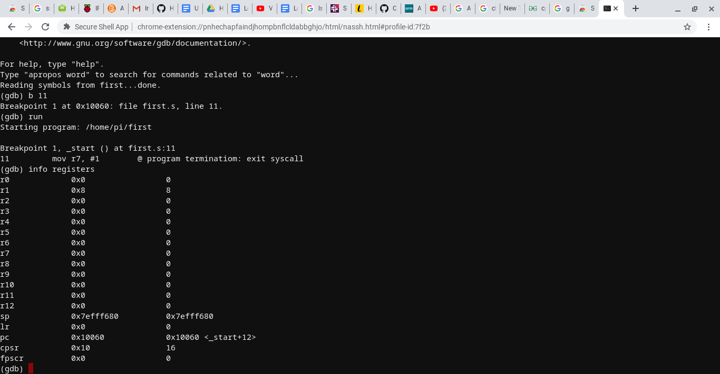

Similar to x86 destination comes first and then the source for mov/add/sub/mul methods. The only difference was that add/sub took three operands instead of two. First thing I noticed is that the register names are different while I was in the gdb debugging. What I didn’t see is the register that held the ALU status flag values.

**Part 2**

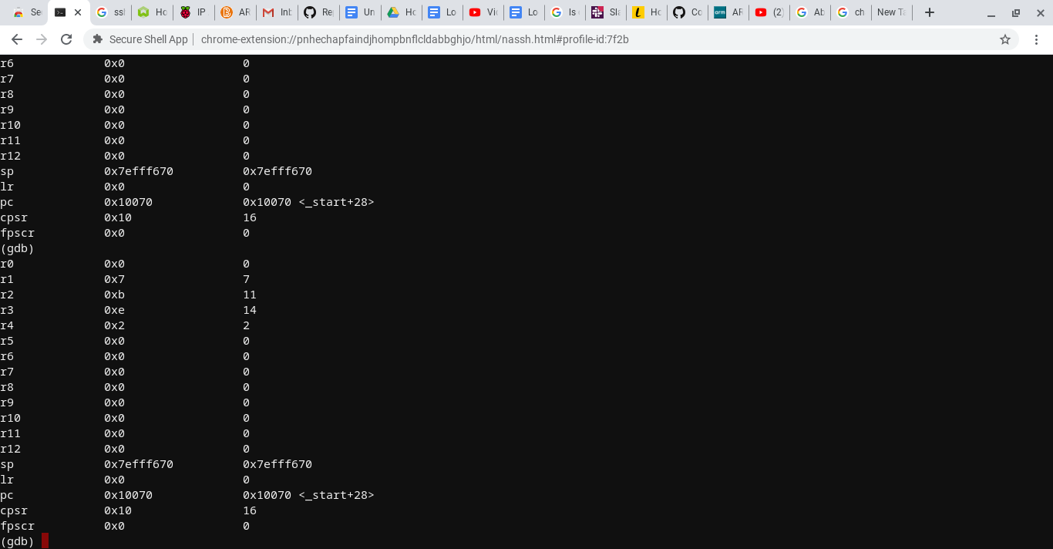

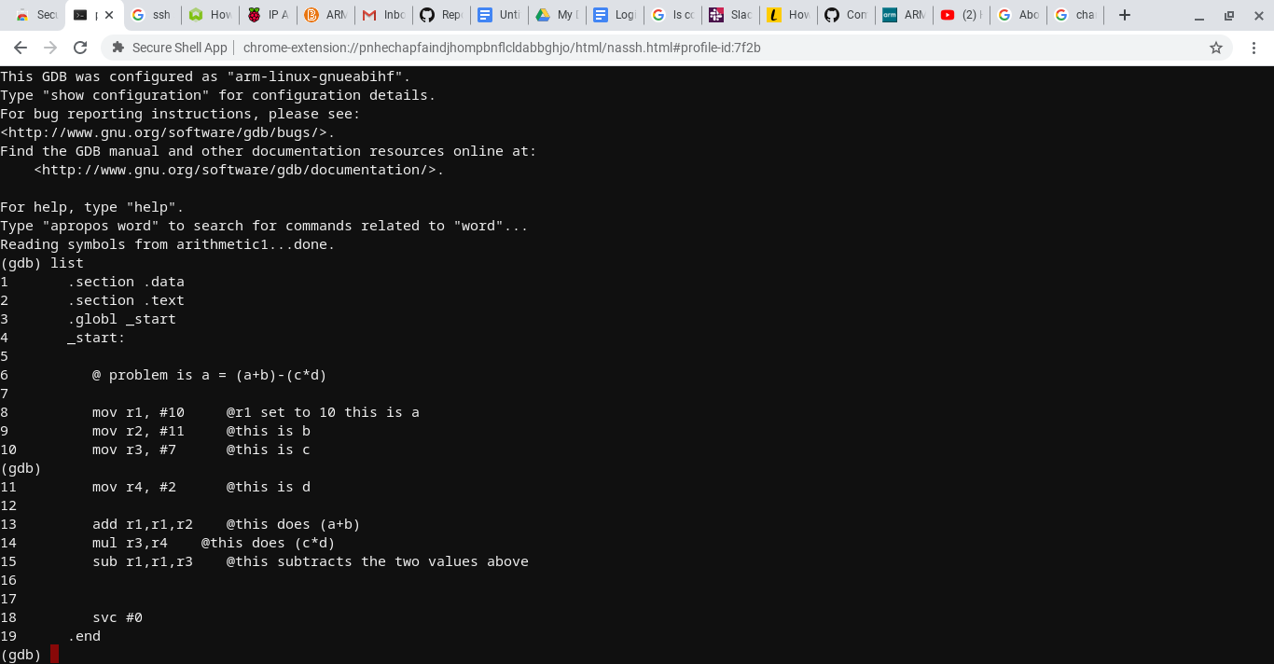

I learned that I could use two operands to multiply numbers together instead of three. Immediate (integers) have a major difference since I had to put the ‘#’ symbol in front of the number. The continue command allows you to proceed after setting multiple breakpoints (Looked up). Learned that cspr is the equivalent to eflags. Also the results in the register are in decimal instead of hex.

**Rayaan Chowdhury**

**Part 1**

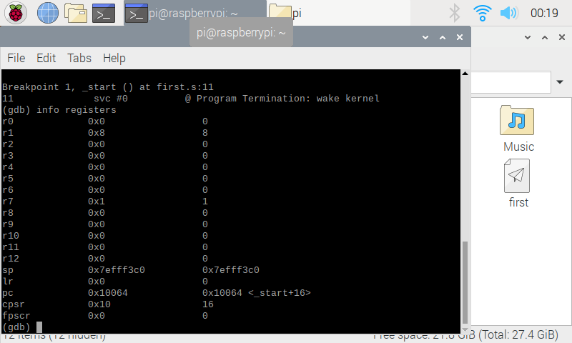

Registers show that the original source code had r1 as 8 because 5 was loaded onto r1 and then the instructions sub r1, r1, #1 and add r1, r1, #4 subtracted 1 from r1 and then added 4 to r1. Equaling 8 which still shows at r1.

**Part 2**

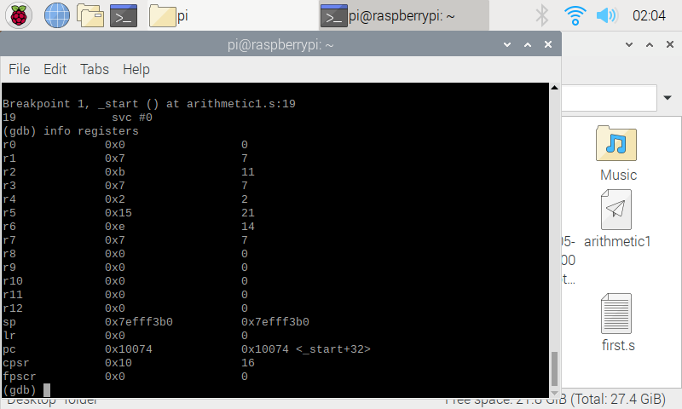

The registers this time around have different values because of the given equation that had to be replicated. So now we are using more than one register. R1 through r7 are now given values. The important values being r1 = 10 , r2 = 11, r3 = 7 , r4 = 2. The registers r5 and r6(and r1) were modified to add and multiply(and subtract) values according to the formula. And r1 was changed from the original value to equal the final answer after all the given arithmetic

**Ilka Jean**

**Part 1**





There’s no output shown, although we assembled the code we did not do any action that will produce in output. We execute the program no instruction was given to print in output. There was no debugger/breakpoint used so we are not stepping into the program to see the values. We only assembled and linked but did not use the gdb.

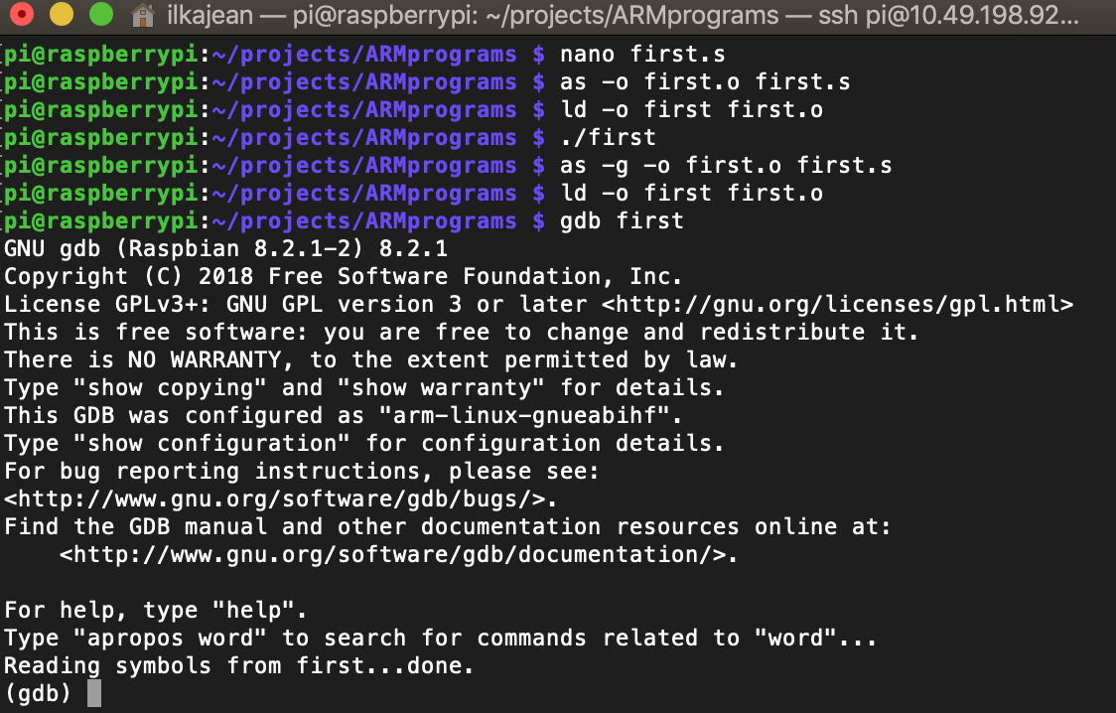

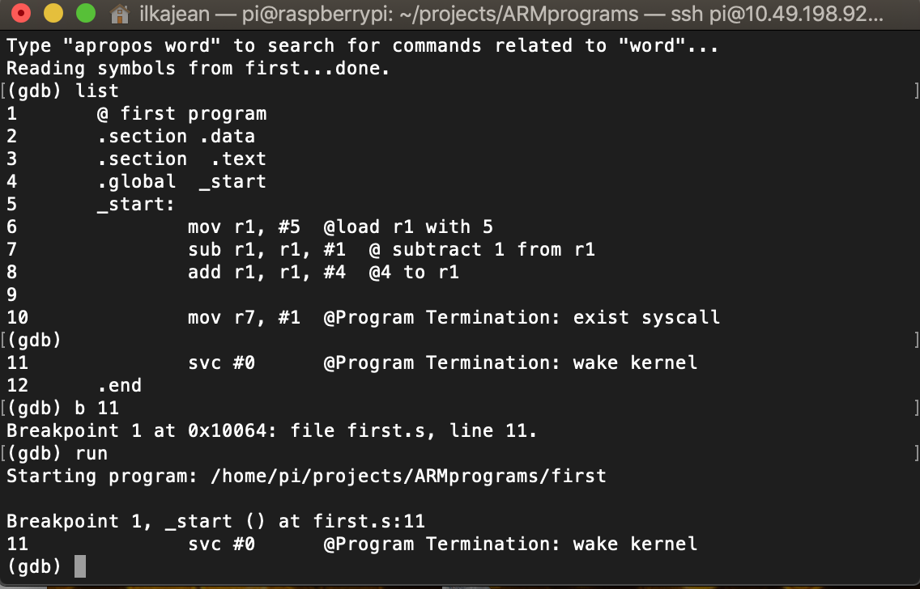

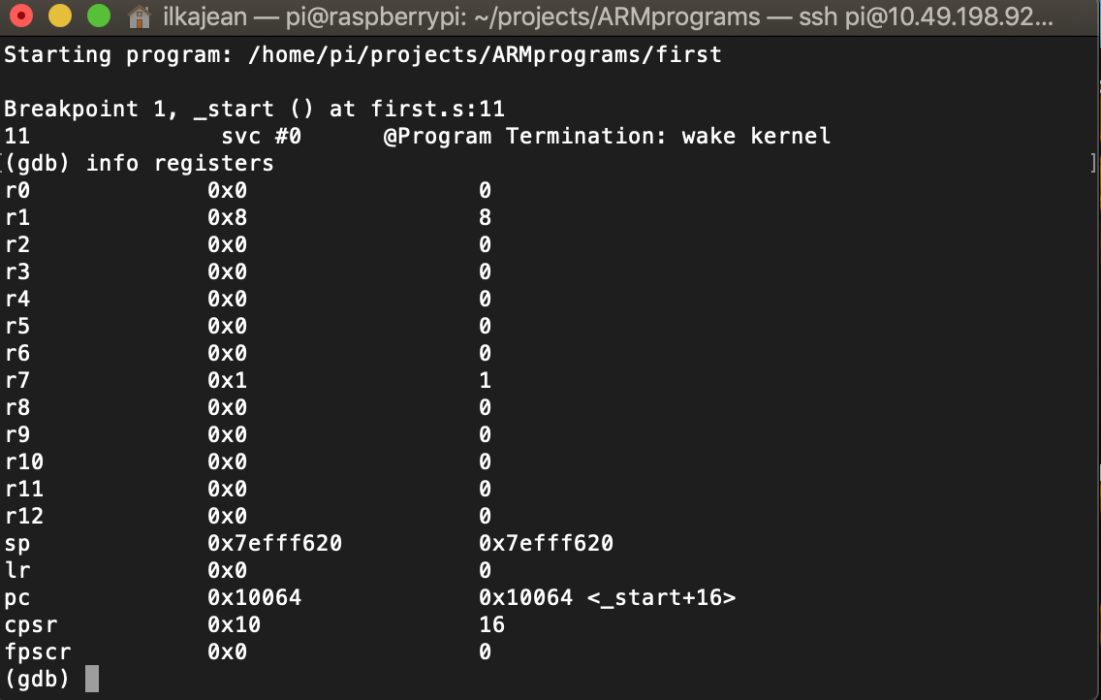

We, first, load the value 5 into register (r1), then we subtract the value 1 from r1 then add the value 4 to register 1. We can see the final value 8 loaded/updated into the r1 register.

**Part 2**

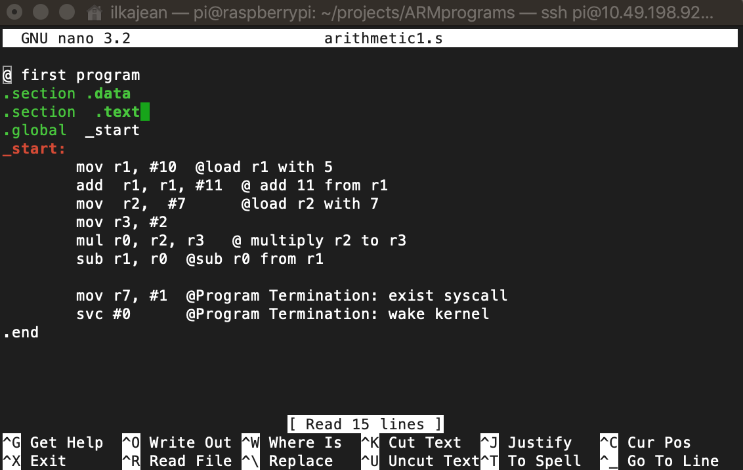

For this program we are using multiple registers to compute A = (A+B) – (C*D). We load the value 5 into register r1 then we add the value 11 into r1. In register r2, we load the value 7 and in register r3 we load the value 2. Using register r0, we multiply r2 to r3. Finally in r1, we subtract r0 from r1. The result is stored in r1. Something I noticed when I was working on this section is that no other register seems to work to multiply, other than r0.

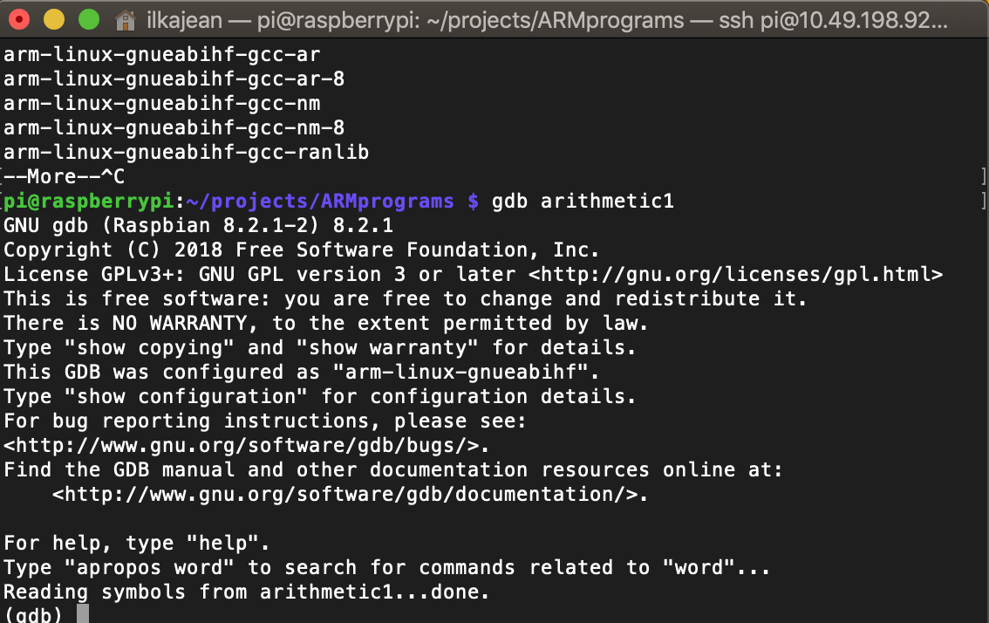

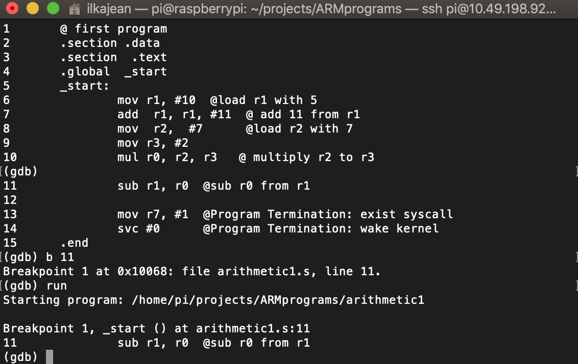

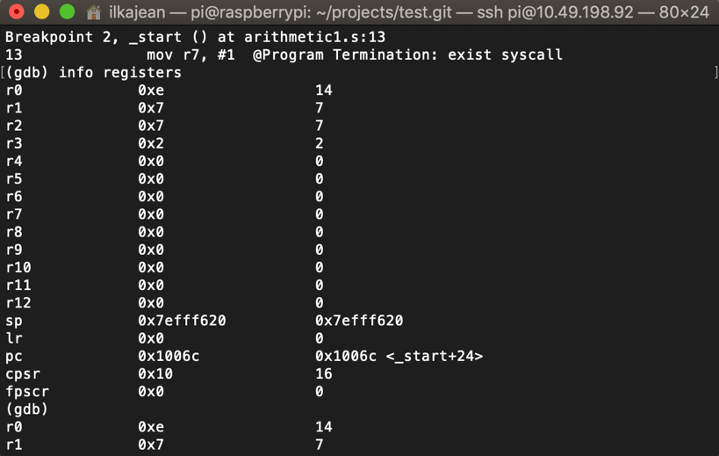

We see that each value is loaded into a register, including their hexadecimal equivalent(14 = 0xe). The final result is stored/updated in r1 because after all the arithmetic, r0 was subtracted from r1.

**Brian Williams**

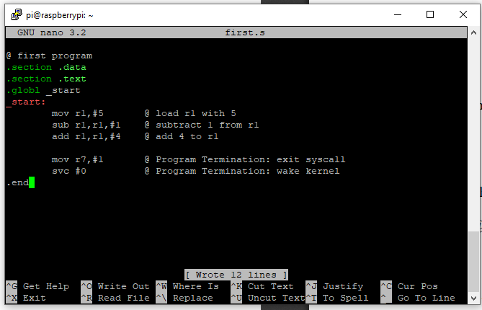

Command Prompt

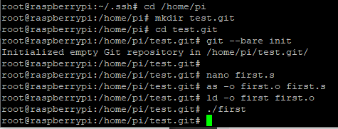

First, I wrote, assembled, and linked the Assembly program Upon running the program, no output appeared in the terminal. I was not expecting an output of any sort because the assembly code written was merely register arithmetic.

GDB debugger:

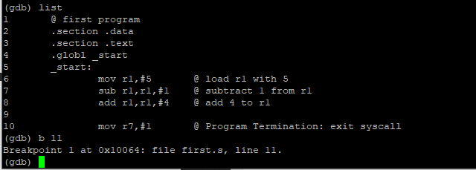

Registers at the breakpoint prior to termination: r1 is 8(5-1+4); r7 is 1, remaining arithmetic registers are 0

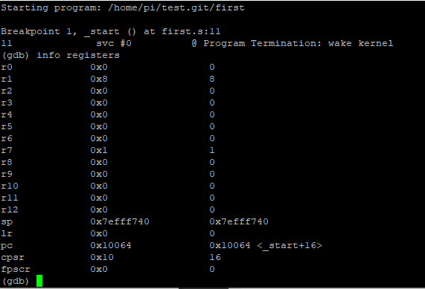

Second program:

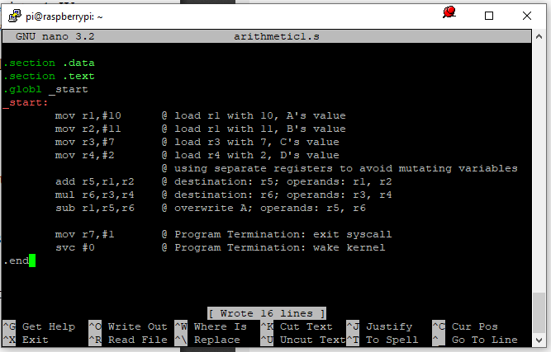

Command Prompt:

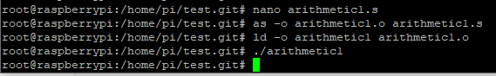

“arithmetic1” was saved, assembled, and linked. After it was run, again, no output.

GDB debugger interface:

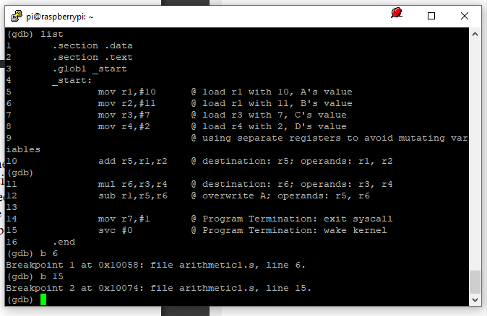

Registers before line 6 (most importantly, before r1 is overwritten): r1 is 10 (as expected), and all other arithmetic registers are 0

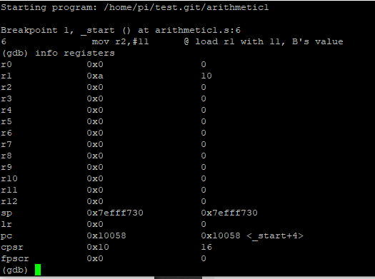

Registers before A is overwritten: r1 is A (10), r2 is B (11), r3 is C (7), r4 is D (2), r5 is A + B (21), r6 is C * D (7 * 2); all values are correct

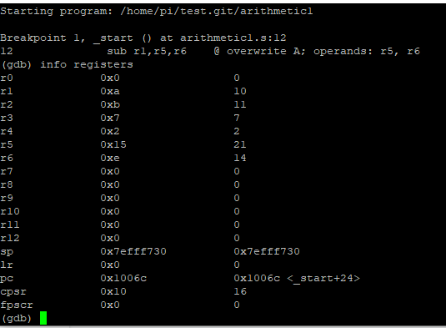

Registers before termination: r1 is (A + B) - (C * D) (7)

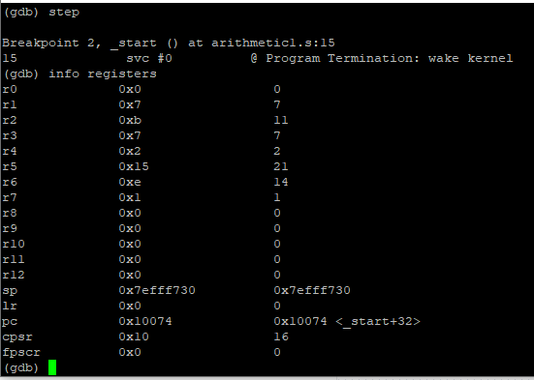

**Mamadou Diallo**

Connecting to GitHub with SSH:

I began by installing Git on the raspberry pi, installed SSH, and then I created the SSH key locally on the raspberry pi. Afterwards, I used the key that was generated by the pi, and on GitHub I created an SSH key with that key. Then, I created an empty git repository, and started working on code inside that file.

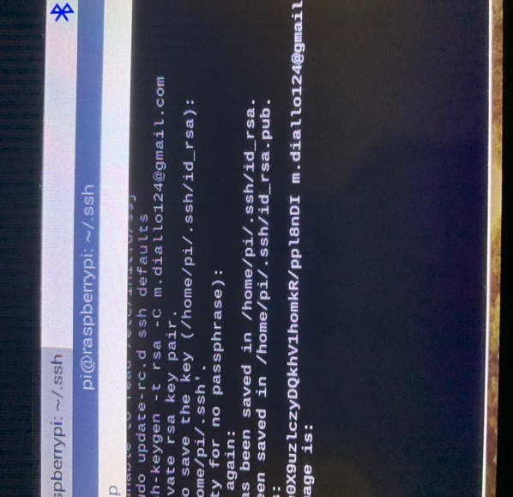 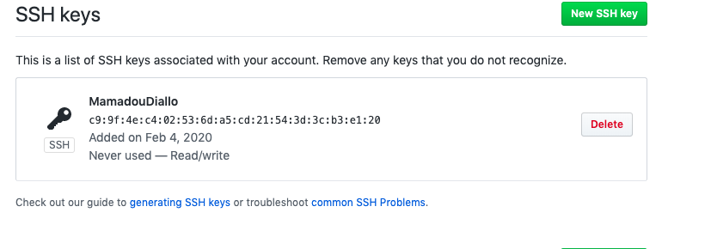

ARM assembler in Raspberry Pi:

In the terminal of the raspberry pi, I began writing my first program by typing “nano first.s”. After writing the program and saving it, I assembled the link, and linked it, so it could become an executable file.

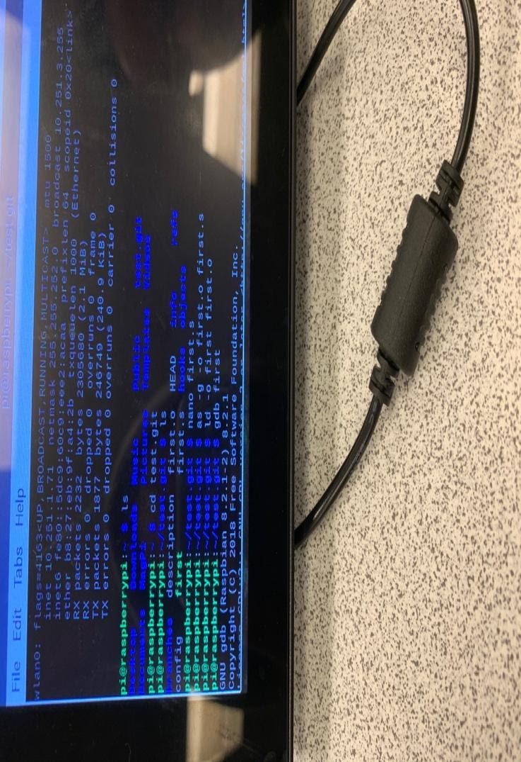

Then, I ran the program, and afterwards, I launched a “GNU Debugger” using various commands. I also learned how to set a breakpoint by typing (gdb) b “11”. After running the program, I also was taught how to view the registers.

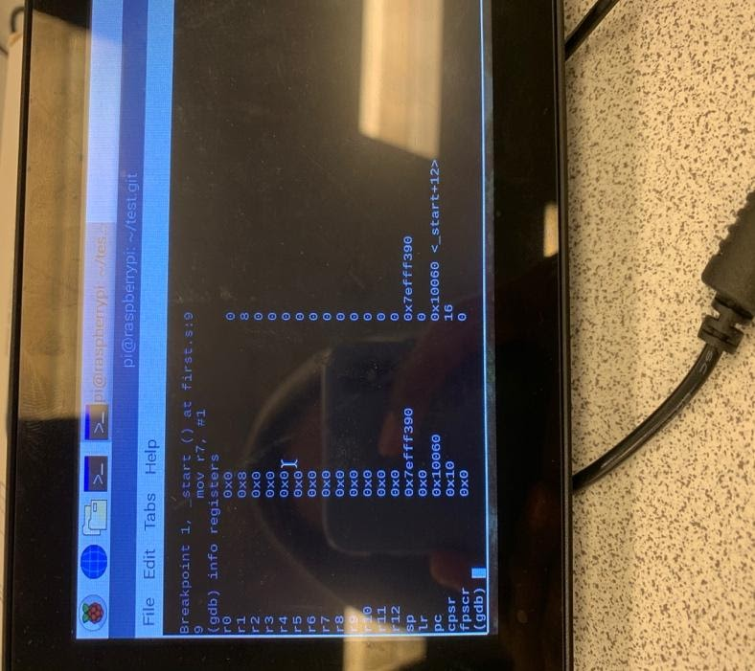

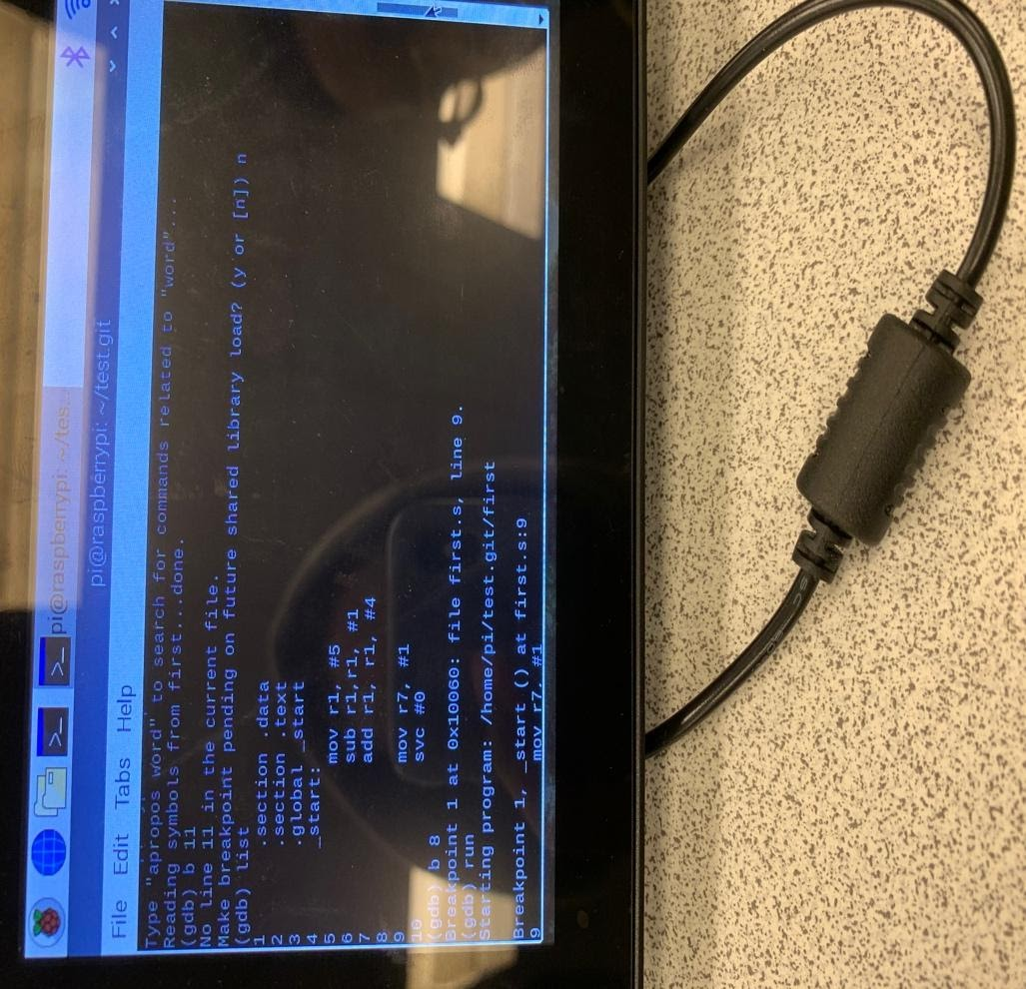

**Part 2**

Next, I wrote another program called “arithmetic1.s that calculated the expression

“A = (A+B) – (C*D)”. I used the same steps to create another program, and I used several instruction operands and stored the values in several registers, before calculating them. In the end, it stored the final value in a register.

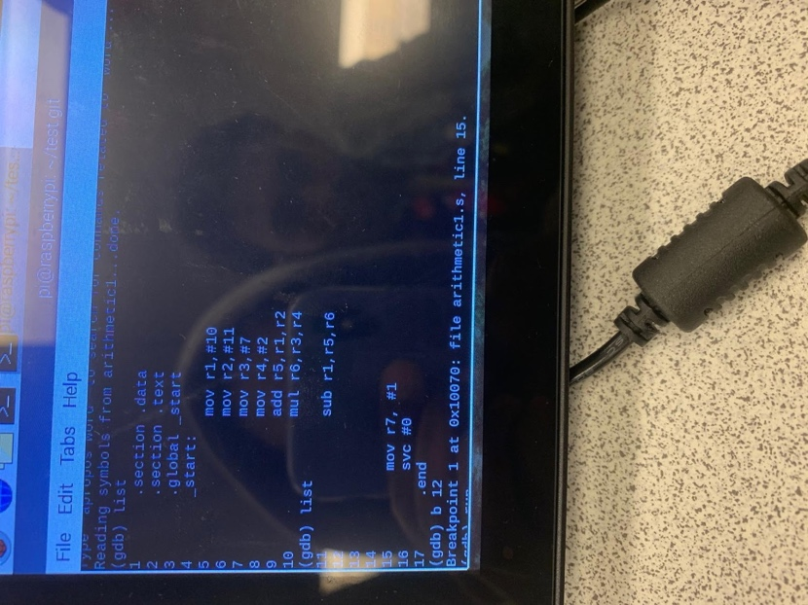

I also assembled and linked the program, before turning it into an executable file, which is shown below.

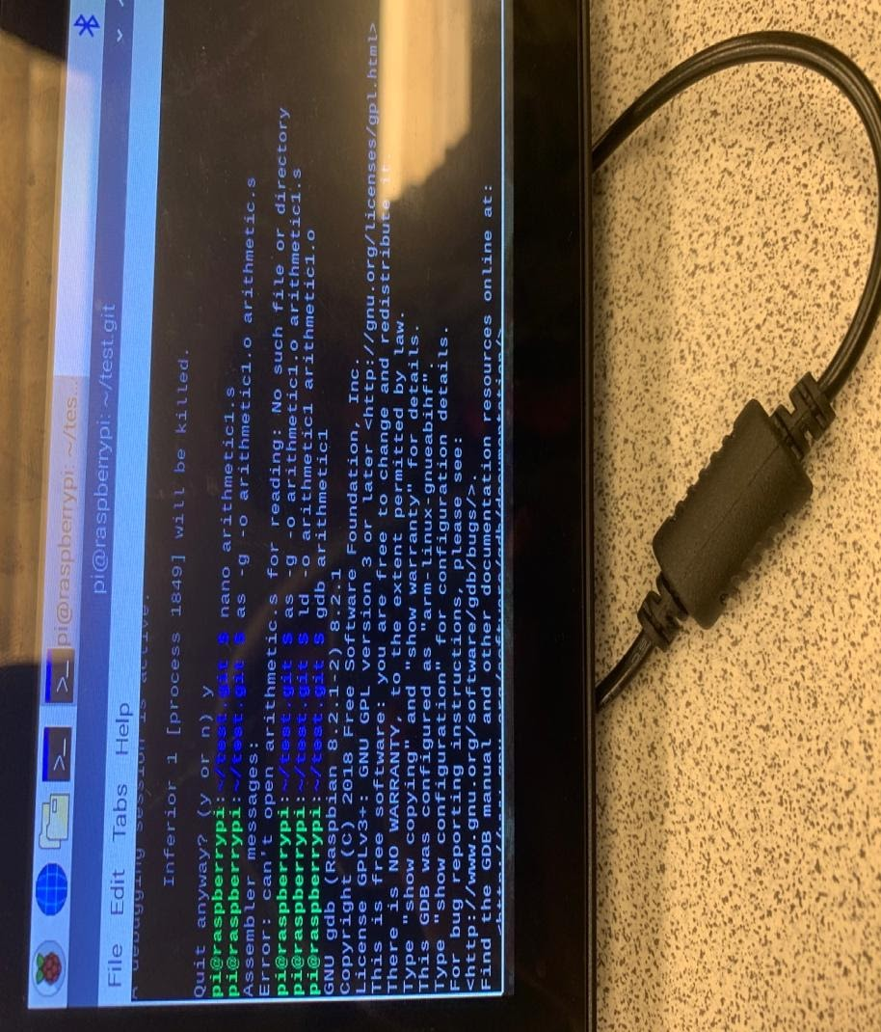

**Appendix**

**Slack**

<https://join.slack.com/t/howaboutbits/shared_invite/enQtOTQxNTM2NjI3NjIyLTc2NjJkZDY2ZjkwOWFiMzRlM2ZjNTgwNzgxOGYzOGRkMzQ4OThjMGYxMmY5YTBjNWI0NjhjNTUzZWEyZTY2ZjM>

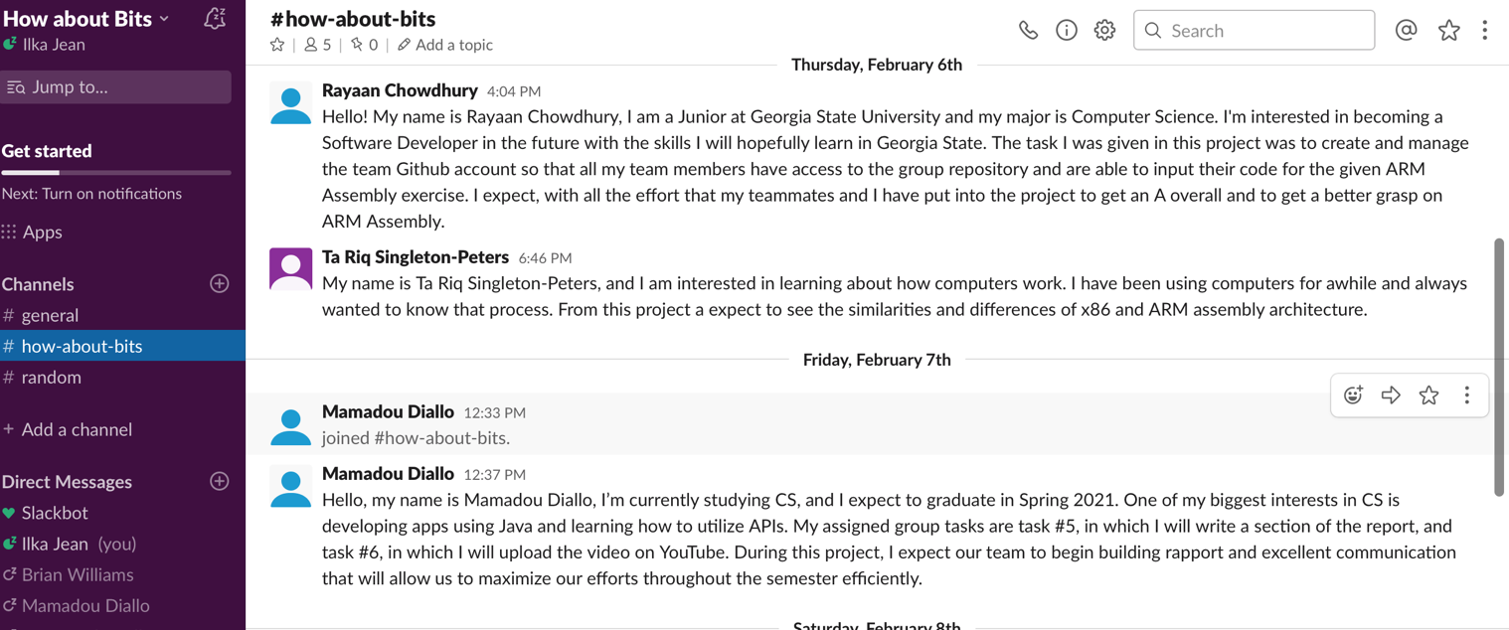

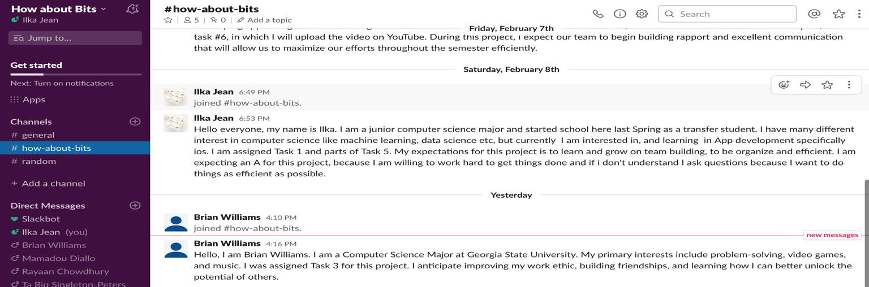

**YouTube**

<https://www.youtube.com/channel/UCKE7zQPcMU6x5kz0OtkaOMg/videos?view_as=subscriber>



**GitHub**

<https://github.com/anotherbyte5/How-about-Bits>



